1. Design an ER diagram for keeping track of information about votes taken in the U.S. House of Representatives during the current two-year congressional session.

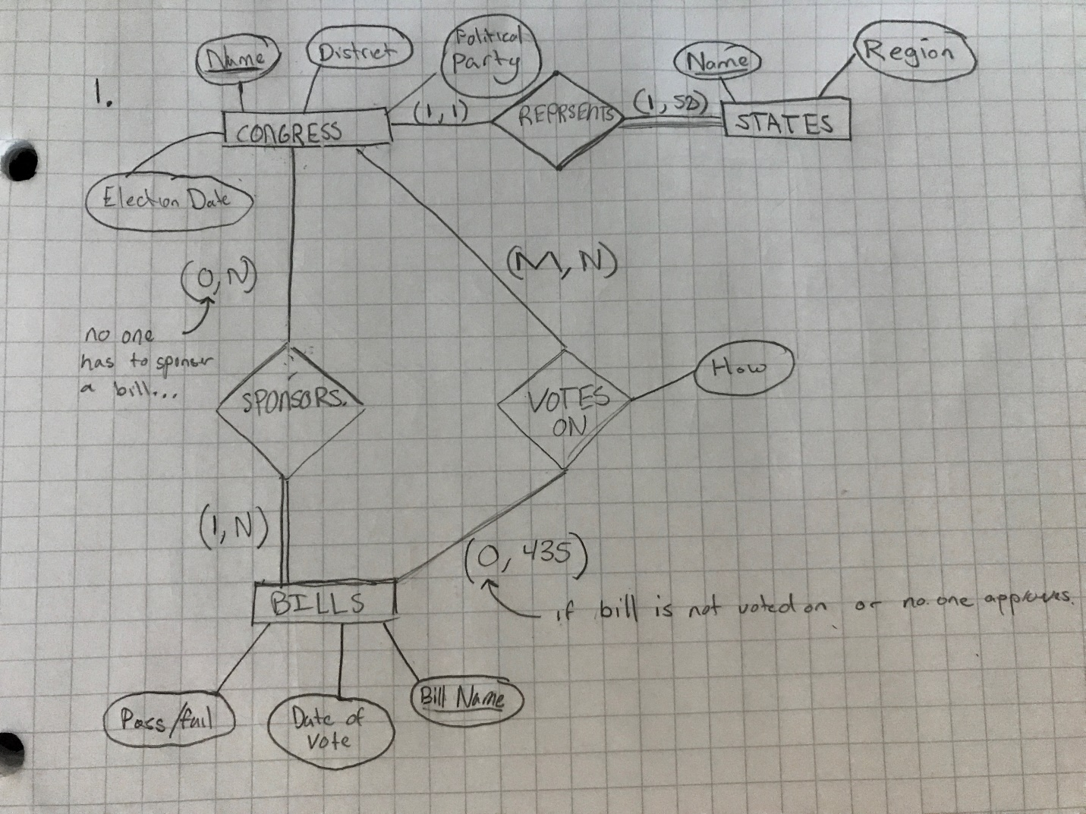

**Note:**

State Name domain restriction includes all states like ‘Texas’, ‘New York’, ‘California’, etc…

Region has the domain restriction of ‘Northwest’, ‘Midwest’, ‘Southeast’, ‘Southwest’, ‘West’.

Political party domain restriction includes ‘Republican’, ‘Democrat’, ‘Independent’, ‘Other’.

Pass/Fail has the domain restriction of ‘Yes’ or ‘No’.

Vote has the domain restriction of ‘Yes’, ‘No’, ‘Abstain’, and ‘Absent’.

**Assumptions:**

For this problem, I assumed that someone from Congress can sponsor a bill but it might not be needed or that a proposed bill that is written does not have a sponsor, thus the (0, N) from CONGRESS to SPONSER. Additionally, when someone from Congress votes on a bill, I assumed that the vote count could be anywhere from 0 to 435 as a bill could be brought up to vote but might not ever be voted on if they run out of time or lack of backing (although would be incredibly rare).

1. Consider the ER diagram in Figure 1. Assume that an employee may work in up to two departments or may not be assigned to any department.

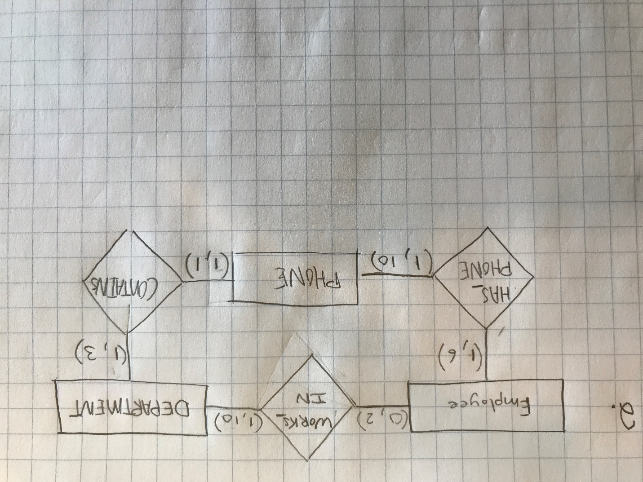

1. Suppose that each of the following update operations is applied directly to the database shown in Figure 2. Discuss all schema-based constraints violated by each operation, if any, and at least 2 different ways to solve such issues (so that no constraint is violated).
   1. *Insert <Robert', 'F', 'Scott', '943775543', '1972-06-21', '2365 Newcastle Rd, Bellaire, TX', M, 58000, '888665555',1> into EMPLOYEE.*

**No errors or constraints violated with the inputted data.**

* 1. *Insert <'ProductA', 4, 'Bellaire', 2> into PROJECT.*

**There is a referential integrity constraint violation for the added department ‘2’. To solve this error, you either can reject change, or add the department ‘2’ into the Dnumber column of the DEPARTMENT table to ensure that the department is available to be added.**

* 1. *Insert <'Production', 4, '943775543', '2007-10-01'> into DEPARTMENT.*

**There is a key constraint and referential integrity violations with this input. First, the department ‘4’ already exists causing the key constraint violation as it would add a duplicate department. Second, the social security number *'943775543'* does not exist in the employee table causing referential integrity violation. To solve these issues, one would either reject or add the employee social security number along with needed data into the Employee table under the Ssn column. After that has been updated, either the department number would need to change or be updated for the current Dnumber from 4 to anything but 5, 4, and 1.**

* 1. *Insert <'677678989', NULL, '40.0'> into WORKS_ON.*

**There is an entity integrity and referential integrity violation for adding this data into the WORKS_ON table as is. The entity integrity violation is due to the Pno number being NULL when it is a primary key of the table which is not possible. The referential integrity violation is due to the social security number *‘677678989'* not existing in the EMPLOYEE table under the Ssn relation. To solve these issues, one would either reject the changes or to change the NULL value to a value that is found in the PROJECT table under the Pnumber relation and update the value of the social security number of *'677678989'* to one that exists in the EMPLOYEE table in the Ssn relation or to add that employee information (including provided Ssn) into the EMPLOYEE table.**

* 1. *Insert <'453453453', 'John', M, '1990-12-12', 'spouse'> into DEPENDENT.*

**No errors or constraints violated with the inputted data.**

* 1. *Delete the WORKS_ON tuples with Essn = '333445555'.*

**No errors or constraints violated with the inputted data.**

* 1. *Delete the EMPLOYEE tuple with Ssn = '987654321'.*

**There is a referential integrity violation with this deletion that needs to be addressed. The violation is caused by other rows in the DEPARTMENT, WORKS_ON, and DEPENDENT tables that rely on the social security number ‘*987654321'* which would cause them to lose entity integrity if the social security number was deleted. To fix this issue, delete the rows with the social security number *'987654321'* first in the DEPARTMENT (Mgr_ssn), WORKS_ON (Essn), and DEPENDENT (Essn) tables or reject the request to delete.**

* 1. *Delete the PROJECT tuple with Pname = 'ProductX'.*

**There is a referential integrity violation with this deletion as data in the WORKS_ON table depends on the Pno. Deleting the row of ‘*ProductX*’ would cause the Pnumber data of 2 to be removed causing the violation. To correct this issue, one can either reject the change or first remove the row that contains the Pno value of ‘2’ in WORKS_ON first before removing the row in PROJECT.**

* 1. *Modify the Mgr_ssn and Mgr_start_date of the DEPARTMENT tuple with Dnumber = 5 to '123456789' and '2007-10-01', respectively.*

**No errors or constraints violated with the inputted data.**

* 1. *Modify the Super_ssn attribute of the EMPLOYEE tuple with Ssn = '999887777' to '943775543'.*

**There is a referential integrity violation with the update of this data. The issue lies with the fact that there is no Ssn of *'943775543'*. To correct this issue, either reject the change or add a new employee row with the Ssn of *'943775543'* to the EMPLOYEE table.**

1. Try to map the relational schema of Figure 3 into an ER diagram. This is part of a process known as reverse engineering, where a conceptual schema is created for an existing implemented database.

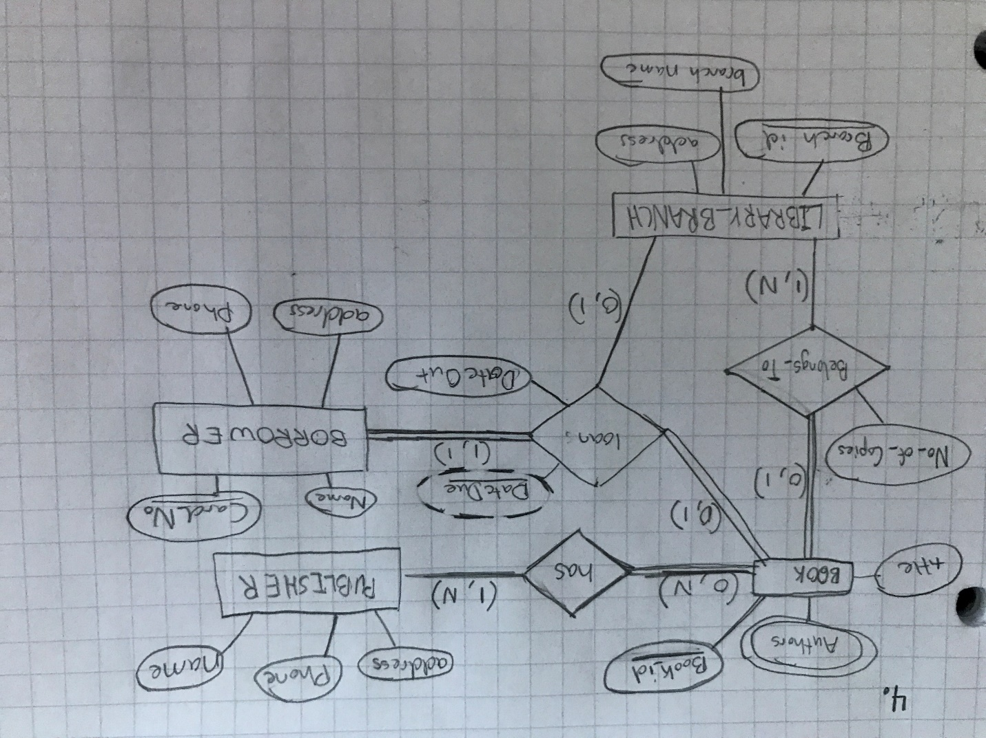

1. Figure 4 shows an ER diagram for a database that can be used to keep track of transport ships and their locations for maritime authorities. Map this schema into a relational schema, an specify all primary keys and foreign keys.

